**Topic Name:**

The main aim of this lab session is to provide hands-on experience on

* Explore file structure
* File management commands
* Absolute path and Relative path
* Globbing
* Scripting

File Structure

1. Under the root directory there are many files like

/bin , /boot , /dev , /etc , ….

Find out the importance of those files

Example : /etc is for user account details

|  |  |  |
| --- | --- | --- |
| **S.No** | **Directory** | **Usage** |
| 1 | / | Root directory |
| 2 | /bin | Binary files |
| 3 | /boot | Boot loader files |
| 4 | /dev | Essential device files |
| 5 | /etc | Host specific configuration files |
| 6 | /home | User home directory |
| 7 | /lib | Libraries essential for binary files |
| 8 | /proc | Virtual file systems providing process and kernel information as file |
| 9 | /sbin | Essential system binaries |
| 10 | /tmp | Temporary files |
| 11 | /var | Variable files |
| 12 | /opt | Optional application software packages |
| 13 | /usr | Secondary hierarchy for read only user data |

1. In Linux, there are three different files

Regular file

Directory

Special file

Block file

Character file

Socket file

Pipe file

Fill the below table:

|  |  |  |  |  |  |  |
| --- | --- | --- | --- | --- | --- | --- |
| File Type | Represented by (Hint ls ) | Role | How to create | How to check | Location | Screen shot |
| Regular file | - | Containing data that can be read and modified by users and processes | touch filename | NA | var/log/,  /etc/,  /home/username/ |  |
| * Text file | - | Contains plain text that can be opened and edited with a text editor | touch filename | NA | /var/log/,  /etc/,  /home/username/ |  |
| * Compressed file | - | Distributing large file after reducing its file size | tar -czvf  filename.tar.gz filename/ | NA | /home/username/,  /tmp/, /var/backups/ |  |
| * Image | - | Image files refer to digital graphics or pictures. These files can be in different formats | NA | NA | /home/username/Pictures/,  /usr/share/icons/,  /var/www/html/ |  |
| Directory | d | To organize files | mkdir directoryName | NA | /bin,/sbin,/etc,/home,/usr |  |
| Block file | b | Linux system administration | NA | NA | /dev/ |  |
| Character file | c | Communication between user programs and hardware device | NA | NA | /dev/ |  |
| Socket file | s | Communication between programs that run on server | NA | NA | /tmp |  |
| pipe file | p | To have interprocess communication | NA | NA | /tmp, /var/tmp |  |

1. Globbing
2. Go back to CYS
3. Create multiple subdirectories using single command

LS

Unit1

command

glob

Unit2

command

grep

Unit3

constructs

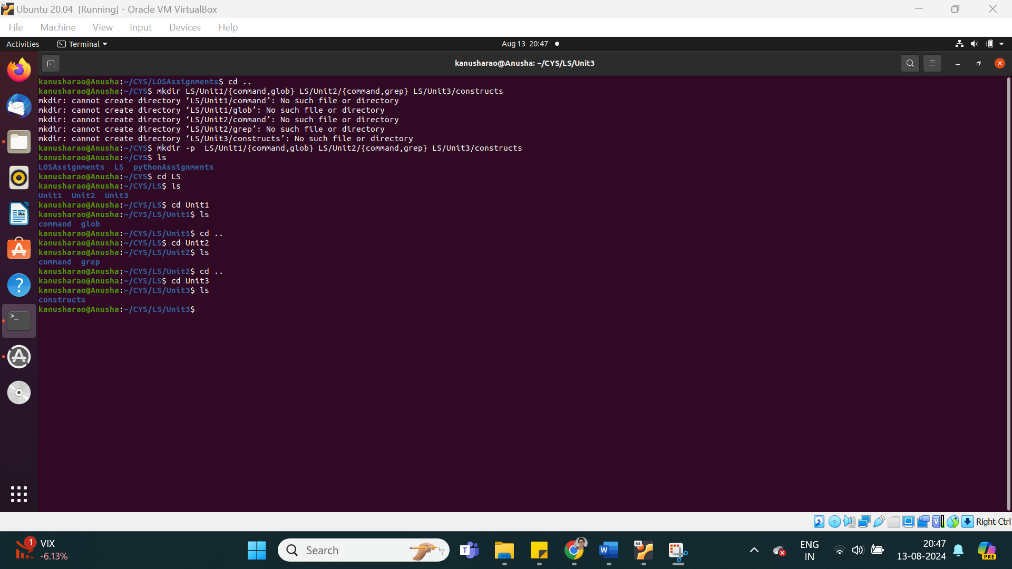

1. Navigate to unit1/glob
2. Create the following files :

Commands.txt

Commands1.txt

Commands2.txt

page1.html

page2.html

page3.html

file1

file10

file11

file2

File2

File3

file33

fileAB

filea

fileA

fileAAA

file(

file 2

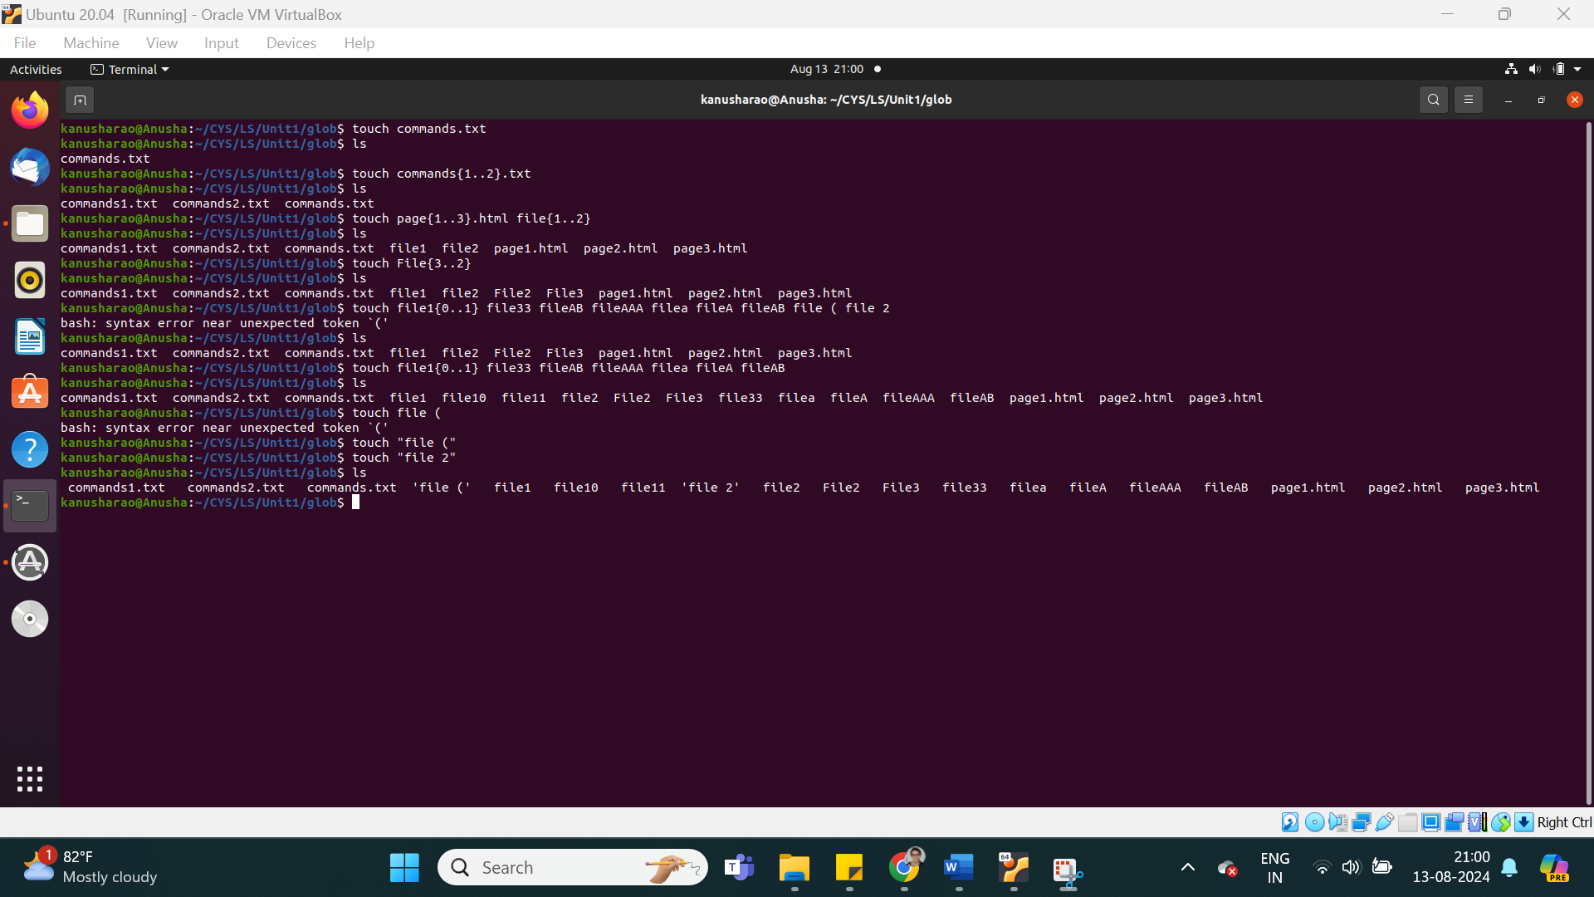

* + 1. List all files starting with file
    2. List all files starting with File
    3. List all files starting with file and ending in a number.
    4. List all files starting with file and ending with a letter
    5. List all files starting with File and having a digit as fifth character.
    6. List all files starting with File and having a digit as fifth character and nothing else.
    7. List (with ls) all files starting with a letter and ending in a number.
    8. List (with ls) all files that have exactly five characters.
    9. List (with ls) all files that start with f or F and end with 3 or A.
    10. List (with ls) all files that start with f have i or R as second character and end in a number.
    11. List all files that do not start with the letter F.
    12. Remove all the *.html
    13. Rename *.txt to *.json

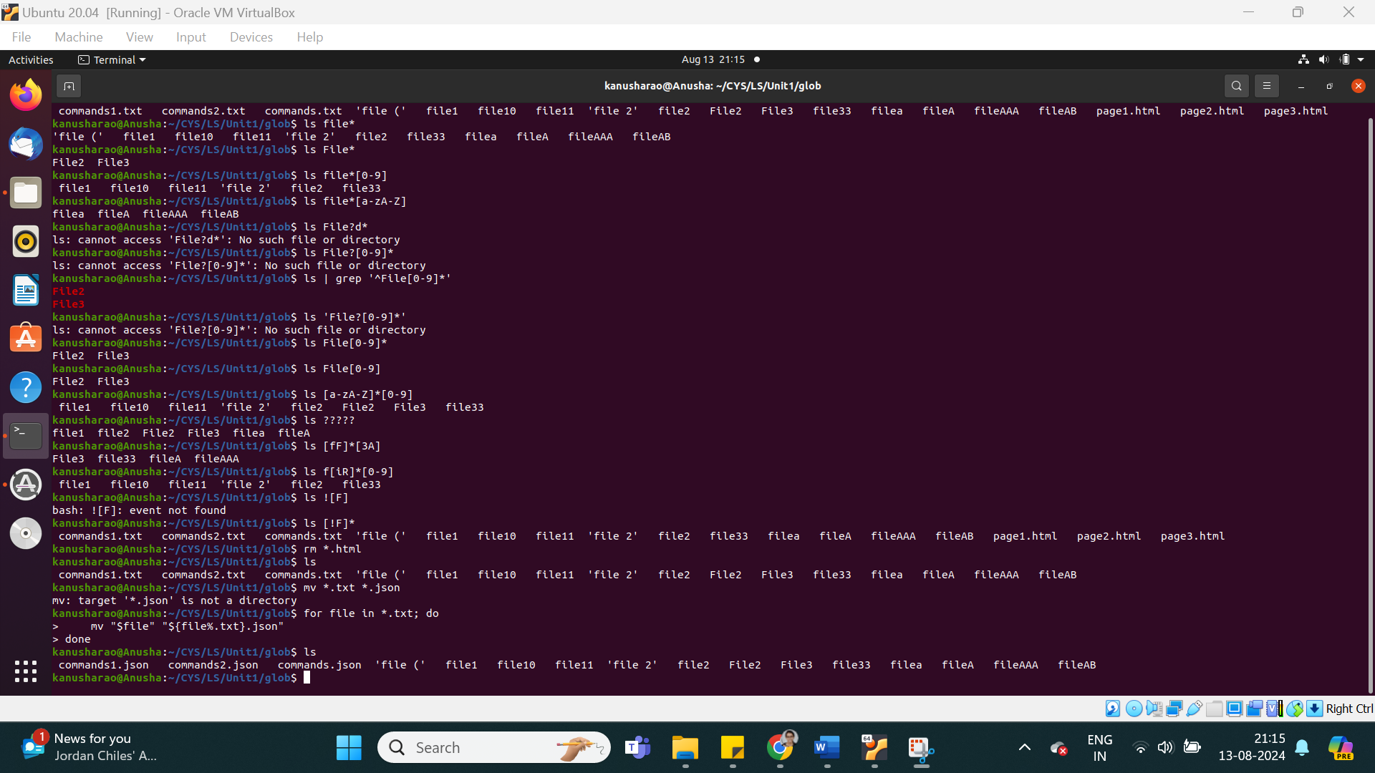

1. Absolute path and relative path

Use rm, mv, cp, ls with absolute path and relative path as per your choice.

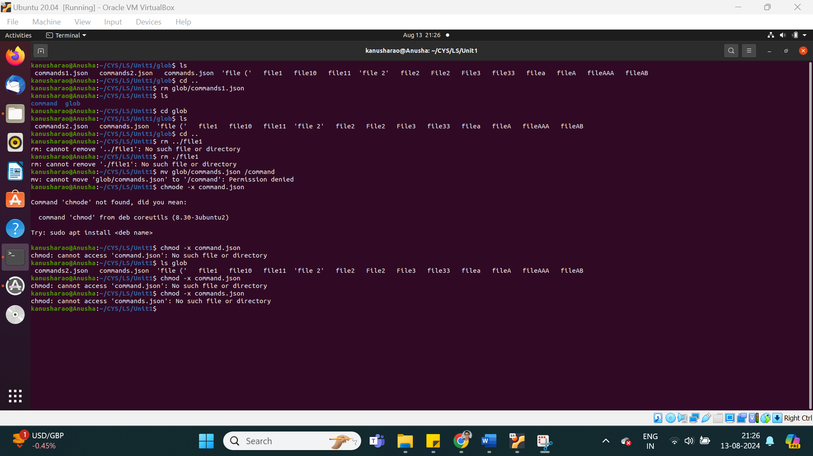 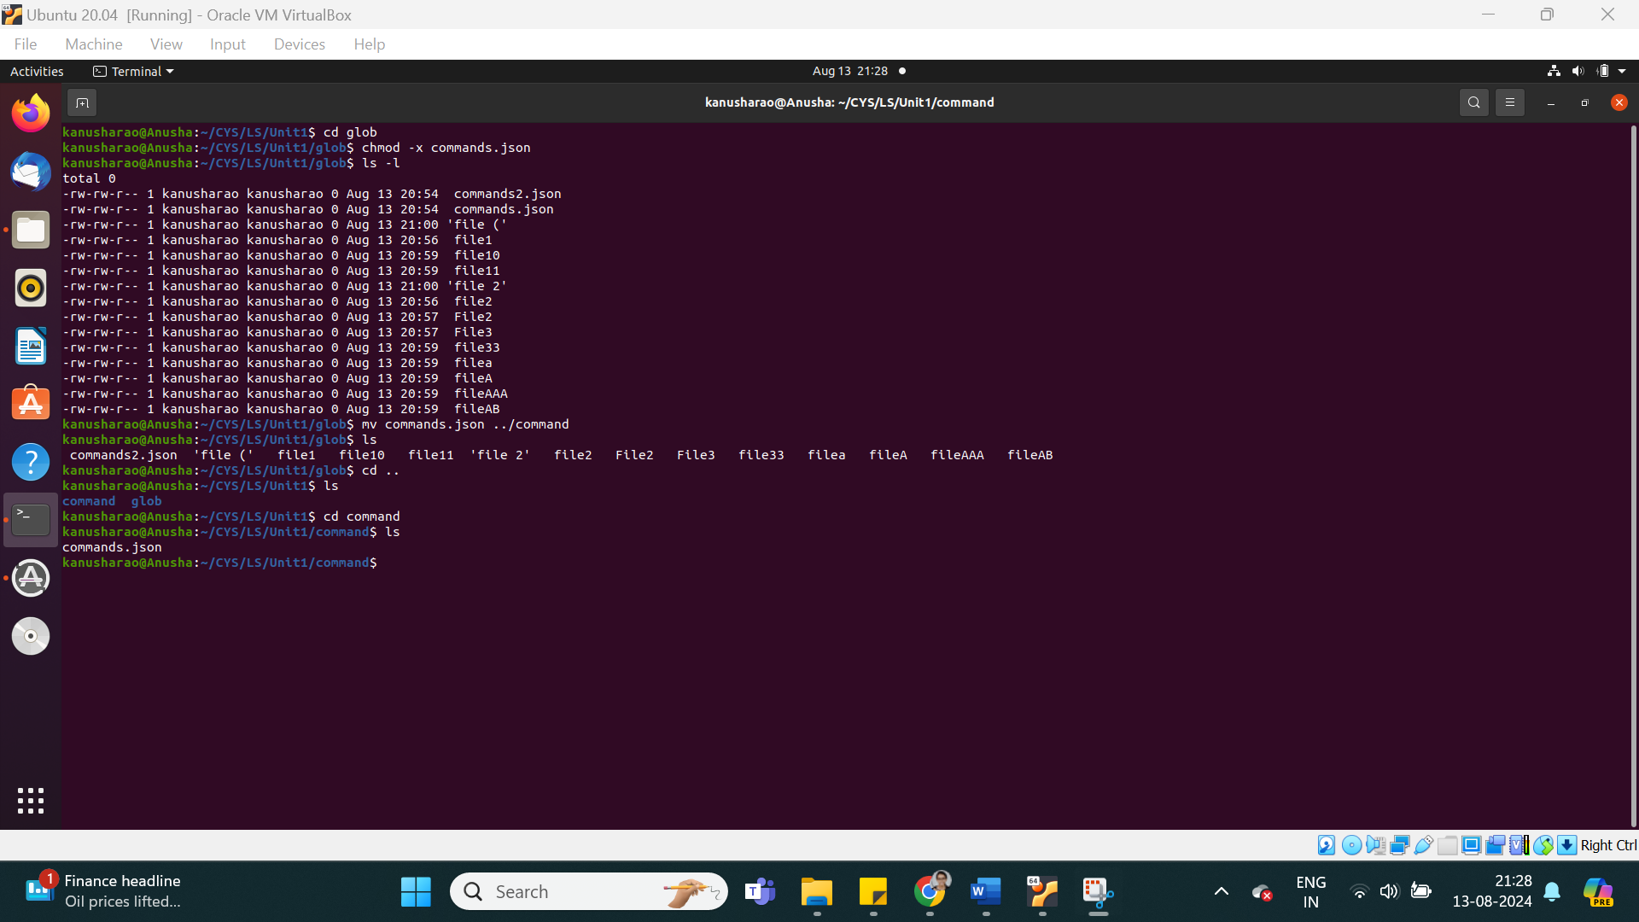

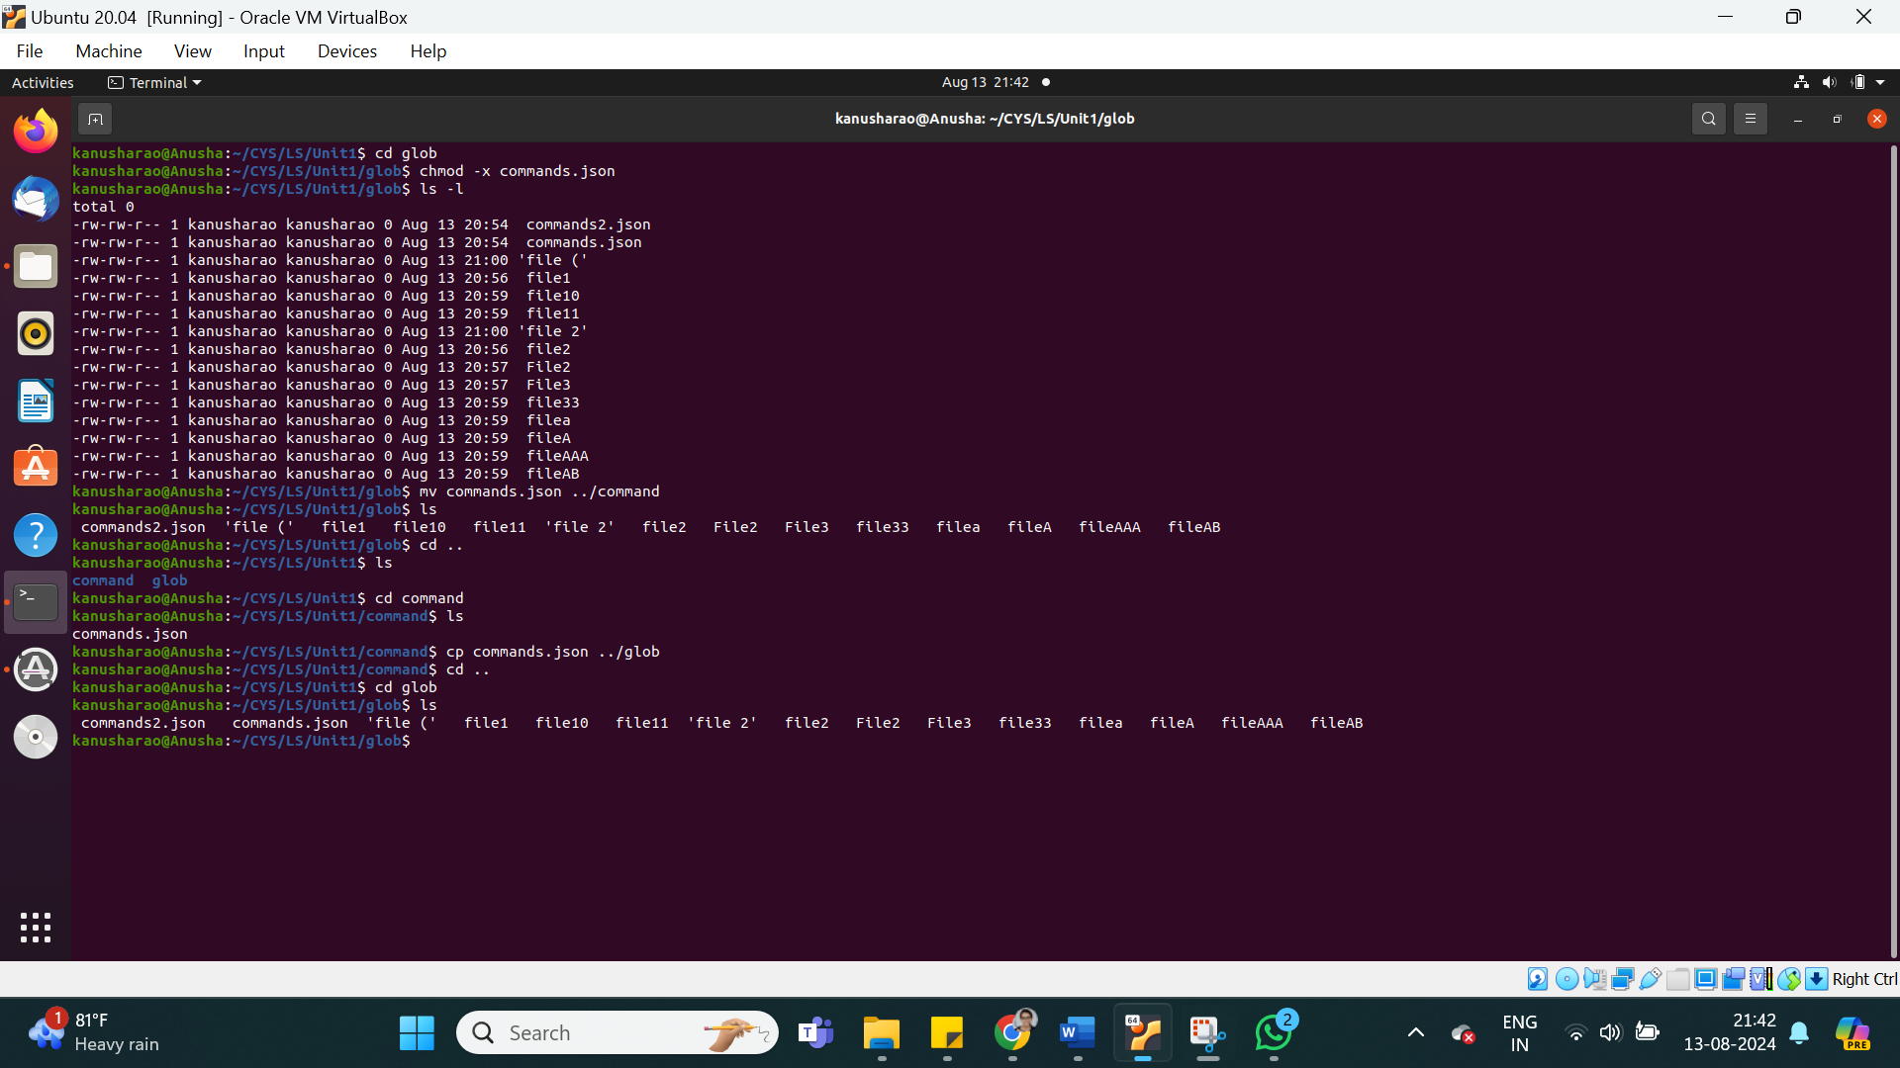

1. Wildcards

|  |  |  |  |
| --- | --- | --- | --- |
| Notation | Use | Example | Screenshot |
| * | Any character | ls *.txt |  |
| ? | Any one character | ls test?.txt |  |
| [ ] | Character class | ls file[1-3].txt |  |
| [! ] | Matches any character that is not a member of the set characters | ls file[!a..z].txt |  |
| { } | To create range | touch a1{1..5} |  |

More on Character class

|  |  |  |  |
| --- | --- | --- | --- |
| Notation | Use | Example | Screenshot |
| [:alnum:] | Prints all those files having alphabets and digits | ls *[[:alnum:]]*.* |  |
| [:alpha:] | Prints all those files having alphabets | ls [[:alpha:]]* |  |
| [:digit:] | Prints all those files having digits | ls *[[:digit:]] |  |
| [:lower:] | Prints all those files having lower case characters | ls ?[[:lower:]] |  |
| [:upper:] | Prints all those files having uppers case characters | ls *[[:upper:]]* |  |

4. change permission

1. Change the permission set of /work/readme.txt so that only the user (owner) can read,write, and execute it. Use absolute mode.

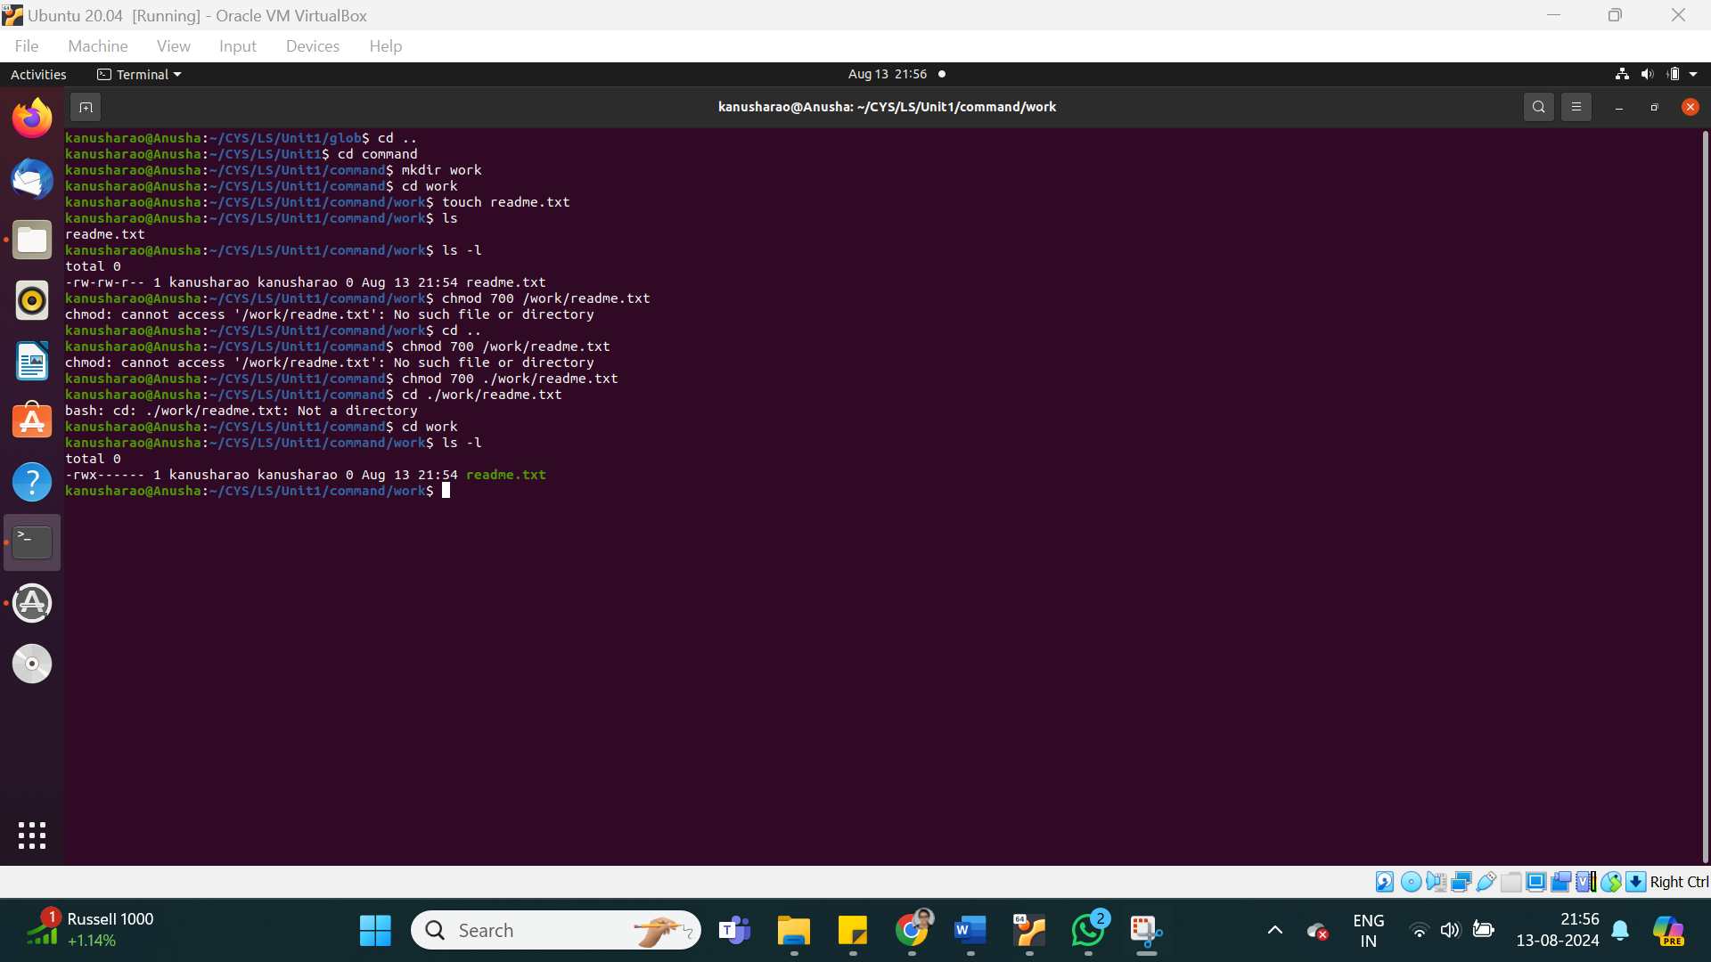

1. Change the permission set of /work/readme.txt so that any user can read it, the group can read/write to it and the user (owner) can read/write/execute it. Use absolute mode.

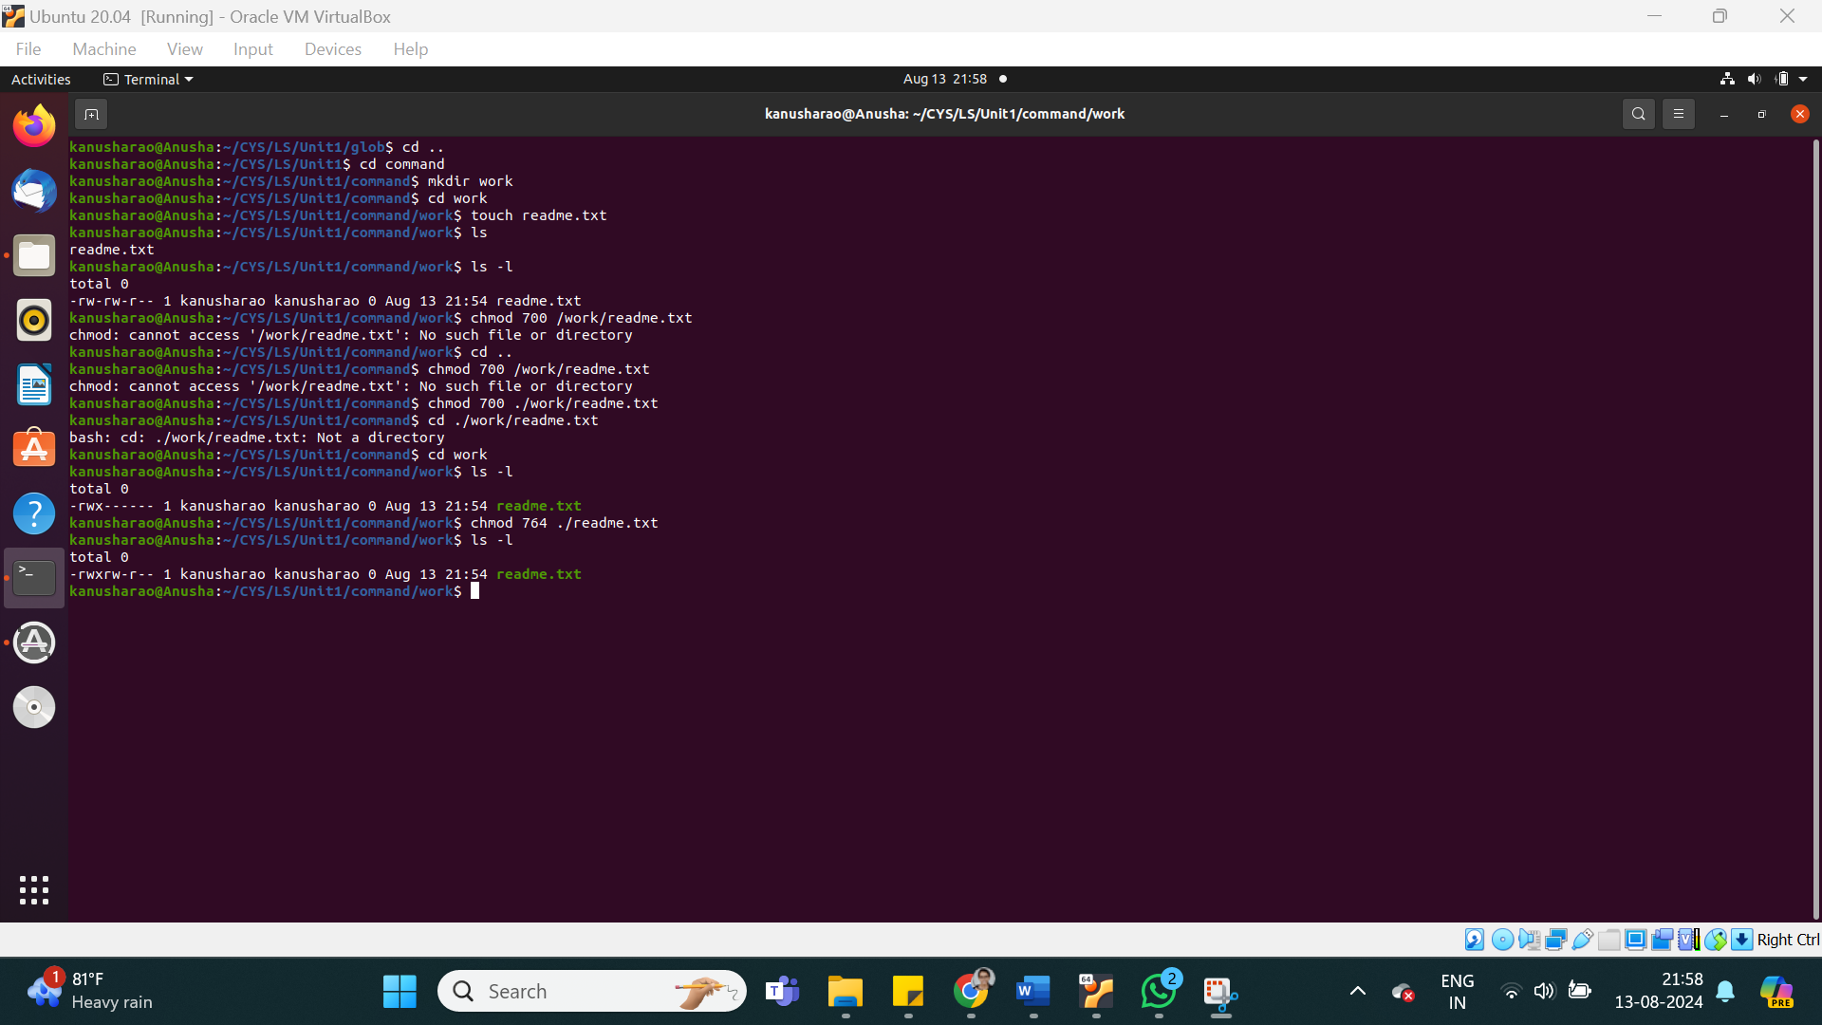

1. Change the permission set of /bin/bash so that only the user (owner) can read/write/ execute, group, and any user can execute it. However, whenever anyone executes it, it should run with the privileges of the owner user. Use absolute mode.

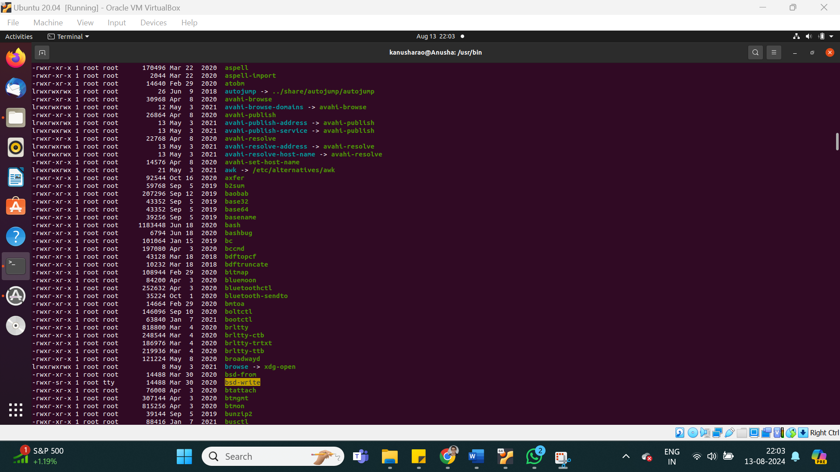

1. Change the permission set of /work/readme.txt so that only the user (owner) can read, write, and execute it. Use relative mode.

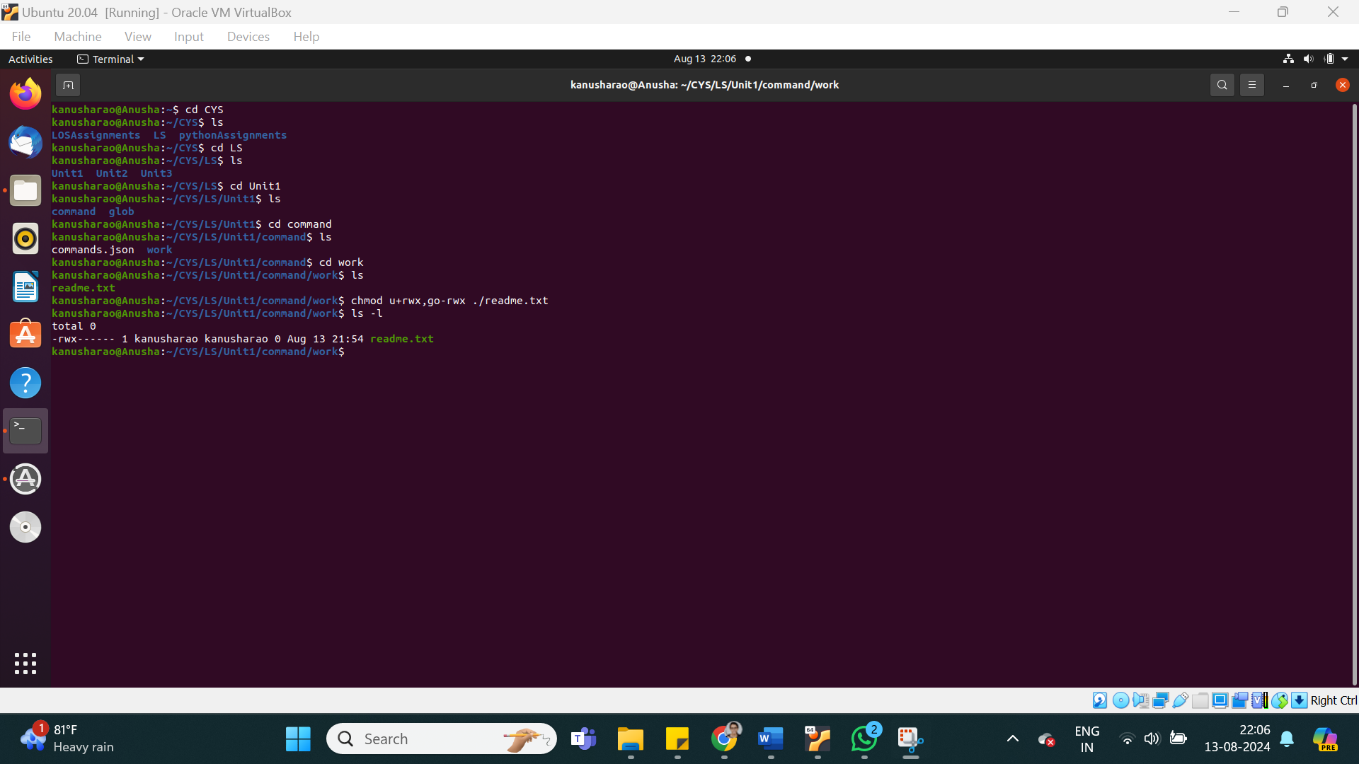

1. Change the permission set of /work/readme.txt so that any user can read it, the group can read/write to it and the user (owner) can read/write/execute it. Use relative mode.

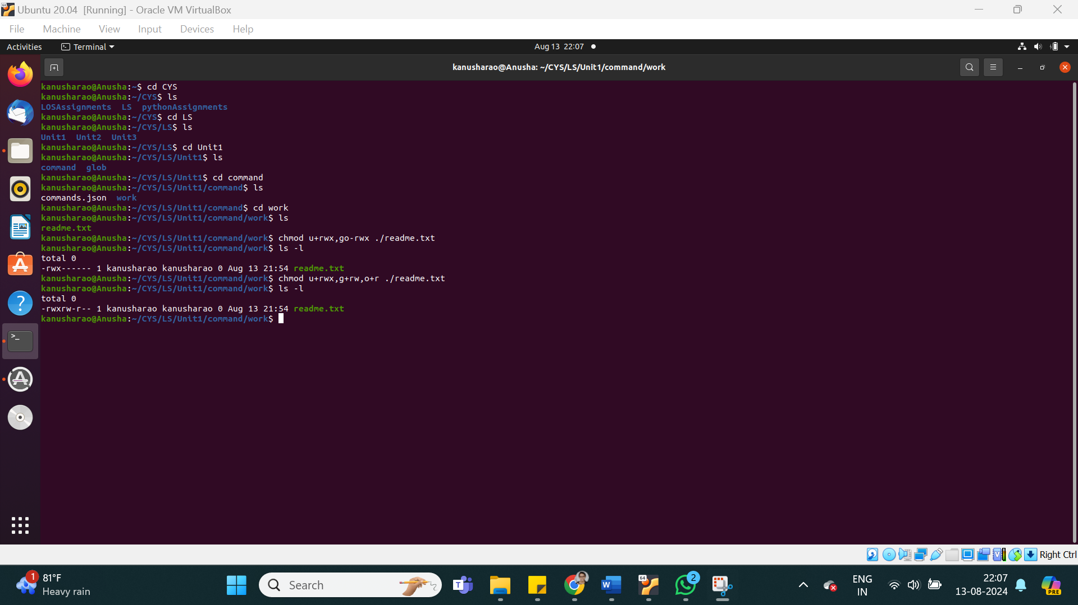

1. Change the permission set of /work/readme.txt so that only the user (owner) can read/write/ execute, group, and any user can execute it. However, whenever anyone executes it, it should run with the privileges of the group. Use absolute mode.

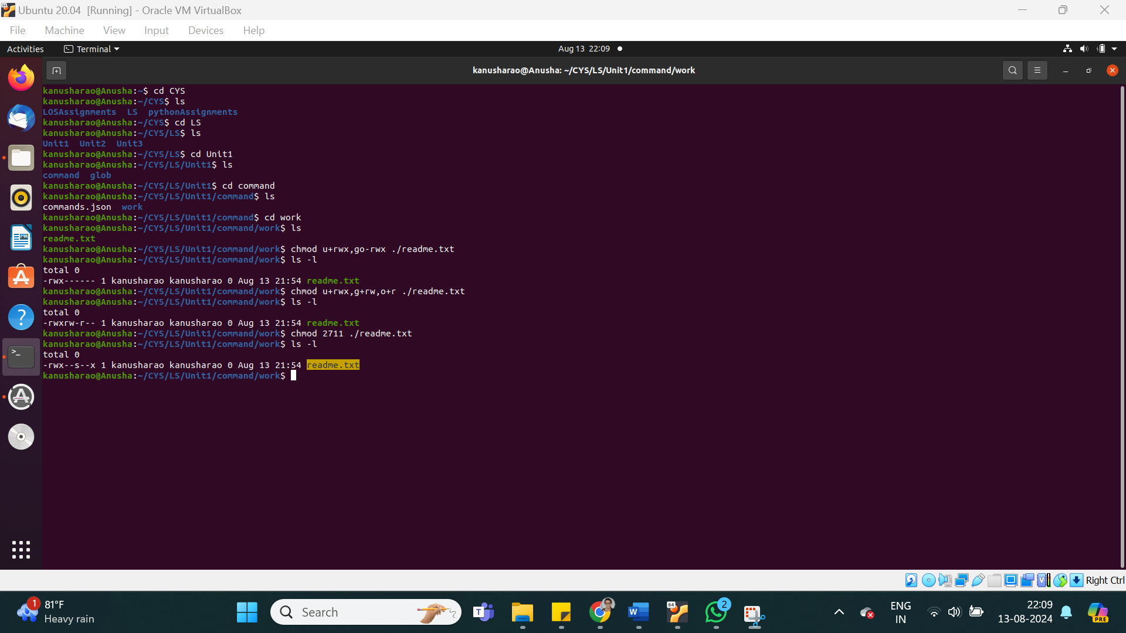

1. Change the permission set of /work/readme.txt so that only the owner can rename or delete this file while maintaining the existing permissions. Use absolute mode.

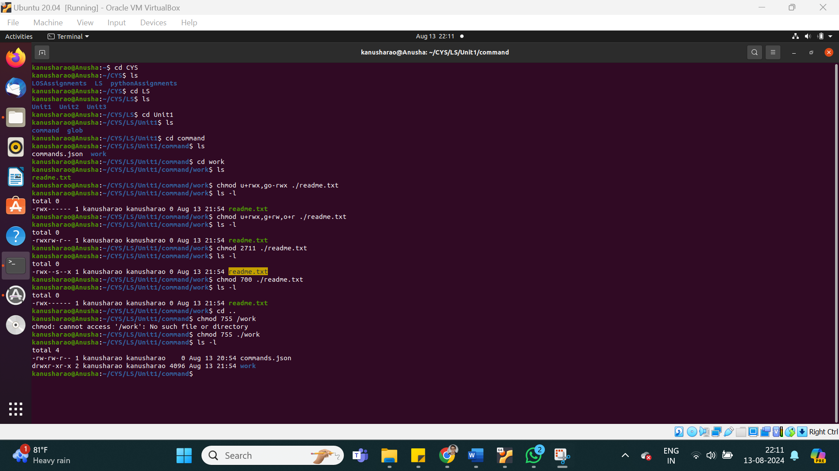

1. What are the default permissions for the new file?

By default:

* **Files** are created with **read** and **write** permissions for the owner.
* **Directories** are created with **read**, **write**, and **execute** permissions for the owner.

1. What was the command to view the file permissions?

**ls -l**

1. Change chmod.exercises permissions to -r--r--r—
2. Change the file permissions to Read only for the owner, group and all other users.
3. What was the command for changing the file permissions to -r--r--r--?
4. Change chmod.exercises permissions to -rw-r-----
5. Change the file permissions to match the following:
   1. owner: Read and Write
   2. group: Read
   3. other: no permissions (None)
6. What was the command for changing the file permissions to -rw-r-----?
7. Change chmod.exercises permissions to -rwxr-x—x
8. Change the file permissions to match the following:
   1. owner: Read, Write and Execute
   2. group: Read and Execute
   3. other: Execute
9. What was the command for changing the file permissions to -rwxr-x--x?

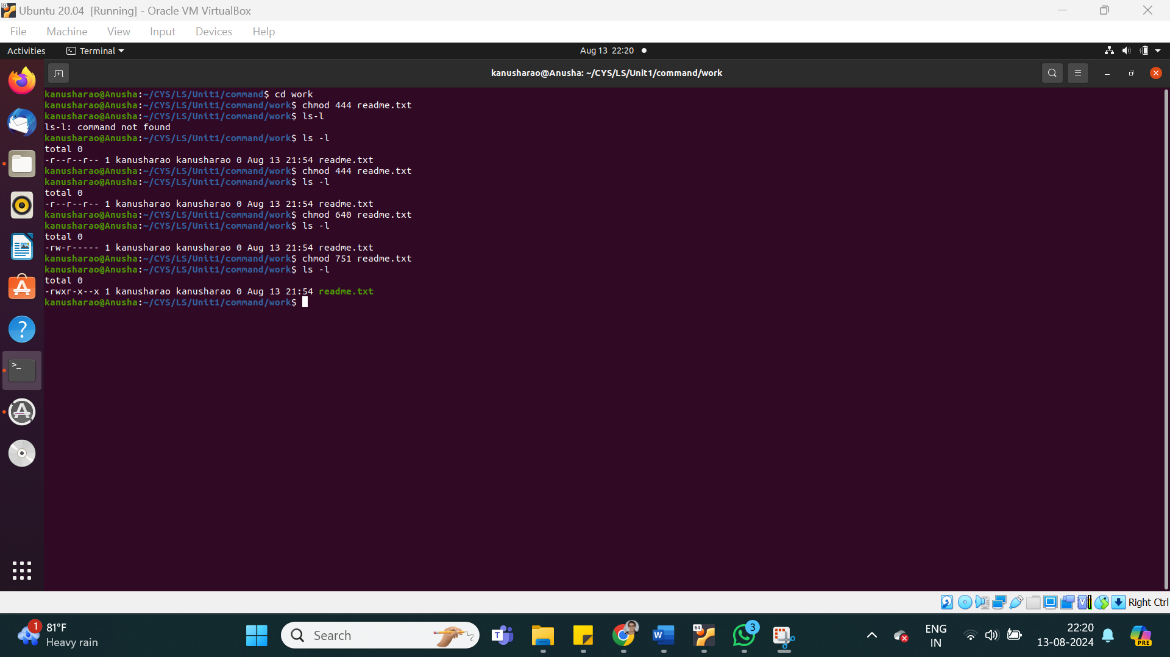

Evaluation :

Marks : 10 (Deadline : 4 – Originality :3 – Completeness :3 )

Deadline: 15.08.2024

In life there are no shortcuts. All things are connected. For success there is no fast lane. Work hard. Focus your energy, practice, remain honest, Truthful, loyal and committed.

-unknown